Valdwin

Make sure the compiler settings set to this

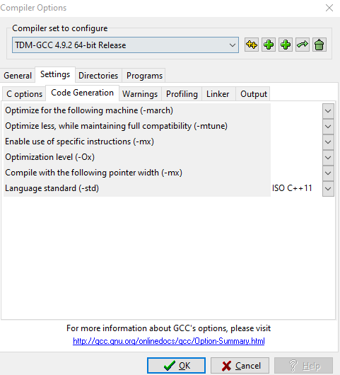

Libraries used

#include <iostream>//input output stream

#include <fstream>//used to manipulate data inside a text file

#include <stdio.h>

#include <stdlib.h>

#include <sstream>//stream string datya

#include <string> //string

#include <ctime>//time

Step one

we have a class where in we declared the mainly user variables of the program that will be used to store the data.

char desc[15];

char supplierN[15];

char IName[15];

int Price;

int qty;

int ROrder;

char category[15];

char UOM[15];

EntryStruct entries[100];

int count;

int count1;

time_t current = time(0); //used for time

string ct = ctime(&current); //used for time

step two

declare the objects that will be used in the class.

void add();

void search();

void list();

void update();

void sell();

void check();

void list2();

void list3();

void sellList();

step three

in the master() inside the master class i made a streaming algorithm for the data inside of it.

Step Four

void add()- ask the user to add data of the item that is to be transferred in the notepad file called masterFile. It also used inheritance it have inherited some of the variable declared inside the master class.

Void search()- in the search file I loaded the master file into the system using an array then I have asked the user what the ID number of the item that needs to be search the then created a loop that will loop until it is not lessthan 11 then output the selected id number with its corresponding data.

void list()- will list all the data once it is called.

Void update()- ask the user what is the id number that will be updated, then ask the user to change the quantity of the item then the item will be updated.then after this there will be an update inside the master list then it will also update the purchase list with the date and time of the update.

void sell() – same as void update() but this updates the sales list which is the list for the sold items.

void check() – this is called in the beginning of the program to check if there is items that are needed to be put inside the out of stock list. How this works is that I loaded the masterlist into an array declared inside of the object. Then I used substring to split the string and get only the number we have also used a function called stoi(str) which converts a string to integer. Then I compare the two with an if else statement to check if the value is lessthan the reorder value. Then get the id number of the out of stock value also using substr() and stoi(). Then used an if else to seach for the value of a string inside the array that was declared earlier if it is equals to the value then it will loop until it reaches 11 then append the value inside the out of stock list.

Void list(),void list2(),void list3() void sellList()- all of them has the same functions but different output .void list() is loaded with the data from the masterlist then append the data when called. Void list2() is loaded with the data from purchases. Void list3 is loaded with the data of out of stock items. Void sellList() is loaded with the data of sales.

Window1

Option1 >>>> window2 access masterlist

Option2 > access purchased items list.

Option3 > display the item in that were sold

Option4 > display the out of stock items

Option5 > terminate program

Window2

Option1> purchase/add item

Option2> search an item by IDNumber

Options3 > update items sold

Options4>list all the data in the master file

Option5> update and restock the item

Option0> return to window1